1. 測試內容：

測試 Meter Counter是否正確計數。

1. 測試環境架構：

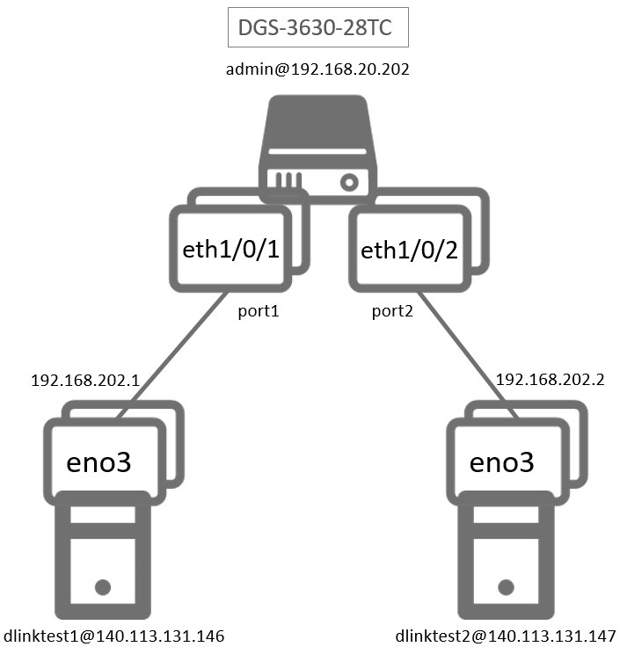

1. 測試環境組態：

* SDN controller: ONOS 1.15.0
* Switch: DGS-3630
* Hosts:
  + ubuntu 16.04.5 LTS
  + dlinktest1(實體機)
    - IP: 192.168.202.1
    - MAC: d0:94:66:5d:5e:08/64
    - Port: 1
  + dlinktest2(實體機)
    - IP: 192.168.202.2
    - MAC: d0:94:66:5c:45:20/64
    - Port: 2
* Apps:

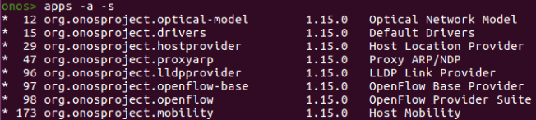

1. 使用之JSON文件：
   * Flow Rule: (附檔：kbpsFlow.json)

|  |
| --- |
| {  "flows": [  {  "priority": 100,  "timeout": 0,  "isPermanent": true,  "deviceId": "of:000078321bdf4000",  "treatment": {  "instructions": [  {  "type": "OUTPUT",  "port": "1"  }  ]  },  "selector": {  "criteria": [  {  "type": "IN_PORT",  "port": "2"  }  ]  }  },  {  "priority": 101,  "timeout": 0,  "isPermanent": true,  "deviceId": "of:000078321bdf4000",  "treatment": {  "instructions": [  {  "type": "METER",  "meterId": 1  },  {  "type": "OUTPUT",  "port": "2"  }  ]  },  "selector": {  "criteria": [  {  "type": "IN_PORT",  "port": "1"  }  ]  }  }    ]  } |

* + Meter Rule: (附檔：kbps.json)

|  |
| --- |
| {  "deviceId": "of:000078321bdf4000",  "id": 1,  "unit": "KB_PER_SEC",  "burst": true,  "bands": [  {  "type": "DROP",  "rate": "1024",  "burstSize": "1024"  }  ]  } |

1. 測試步驟：
2. ONOS GUI:

* Flow View

Flow Entry which entered to meter table showed the “packet count” increased.



* Meter View

Meter Entry as id=0x1 showed “byte count” and “packet count” are zero.



1. Monitor: using iperf tool
   1. Let h1 be udp client, sending 50Mbits UDP traffic to h2, which is a udp server.

|  |
| --- |
| dlinktest1@140.113.131.146: $ iperf -u -c 192.168.202.2 -p 5001 -B 192.168.202.1 -b 50M -f M -t 8 -i 1 |

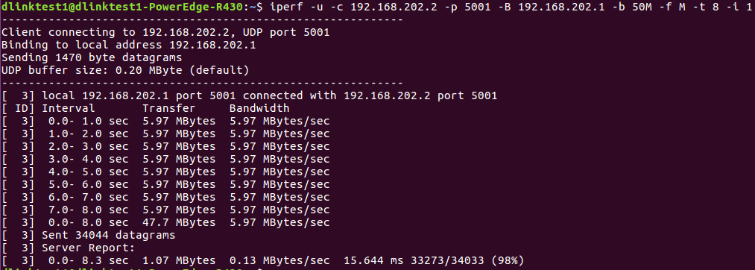

|  |
| --- |
| dlinktest2@140.113.131.147: $ iperf -s -u -f M -i 1 |

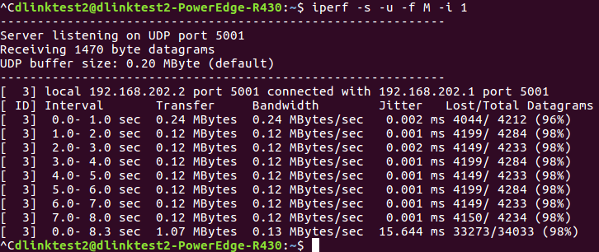

上圖可以看出每秒大約只能傳0.12MB = 0.96Mb

* 1. Let h1 be udp client, sending 120Mbits UDP traffic to h2, which is a udp server.

|  |
| --- |
| dlinktest1@140.113.131.146: $ iperf -u -c 192.168.202.2 -p 5001 -B 192.168.202.1 -b 120M -f M -t 8 -i 1 |

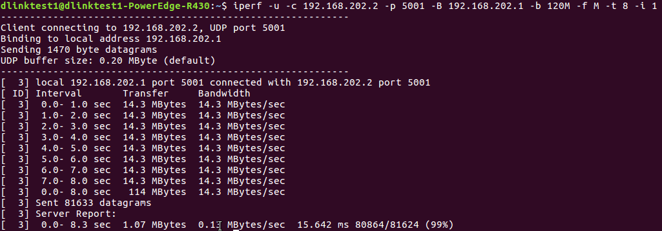

|  |
| --- |
| dlinktest2@140.113.131.147: $ iperf -s -u -f M -i 1 |

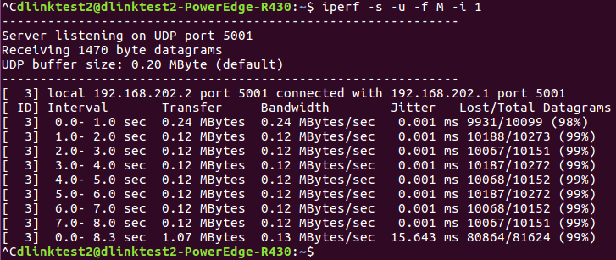

上圖可以看出每秒大約只能傳0.12MB = 0.96Mb

* 1. Let h1 be udp client, sending 240Mbits UDP traffic to h2, which is a udp server.

|  |
| --- |
| 1. dlinktest1@140.113.131.146: $ iperf -u -c 192.168.202.2 -p 5001 -B 192.168.202.1 -b 120M -f M -t 8 -i 1 |

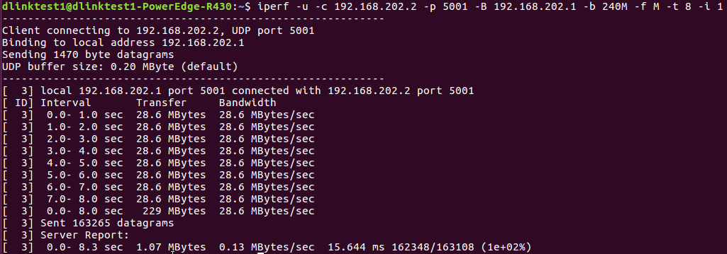

|  |
| --- |
| dlinktest2@140.113.131.147: $ iperf -s -u -f M -i 1 |

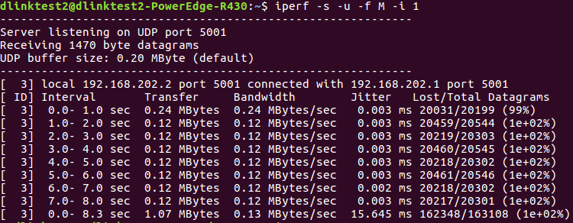

上圖可以看出每秒大約只能傳0.12MB = 0.96Mb

1. 測試結果：

Meter Counter無法正確計數，Flow Counter可以正確計數。